INTRODUCTION TO C
C is a
- It is a high level / middle level programming language.
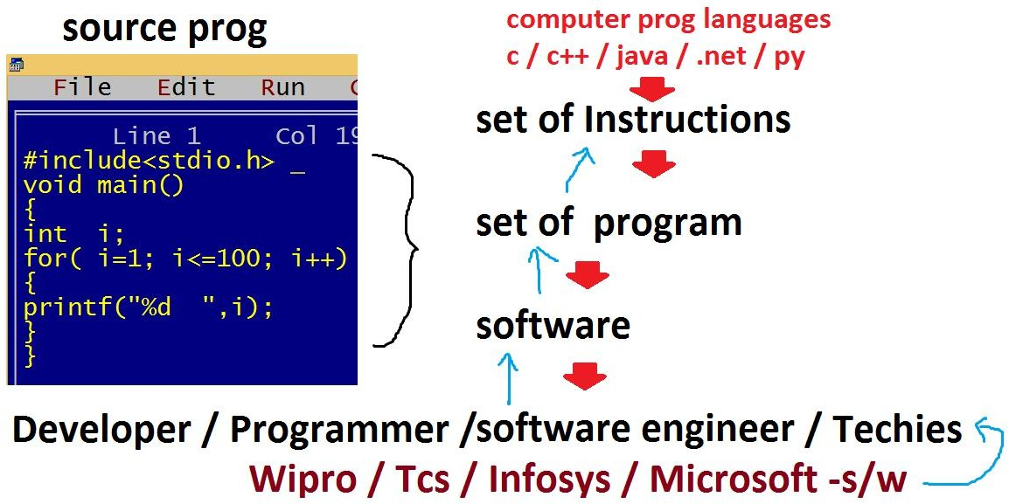
What is a program?
Set of instructions is called program. What is a software?
Set of programs is called software. Or As per the IT industry software is a digitalized and automated process.

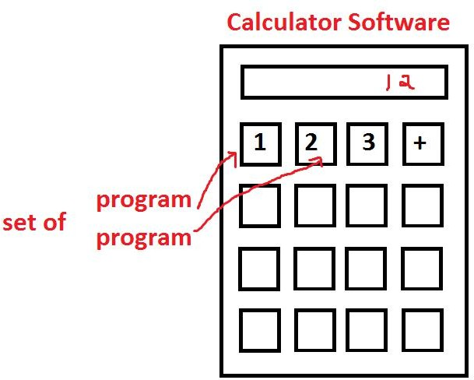

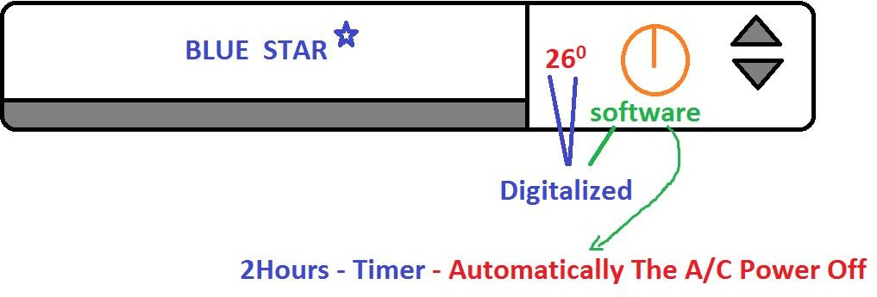
Basically the software divided into 2 types.
- System software

Eg: operating system, device drivers, translators
- Application software
Eg: phonepe, whatsapp, instagram, irctc,…..
What is a language?
Generally the languages like telugu / English / hindi etc are called human languages, which are used to communicate with humans. The languages like C / C++ / Java / .Net / Python etc are called computer programming languages, which are used to develop the programs [ software ] to communicate with the machines to make our work efficient and accurate.
Basically the languages are divided into 3 types.
- Machine language: It is created with binary code[0,1] Eg: 10001111
- Low level / assembly language: Created with English like shortcuts called MNEMONICS.
Eg: add, sub,…
Example for low / assembly language:

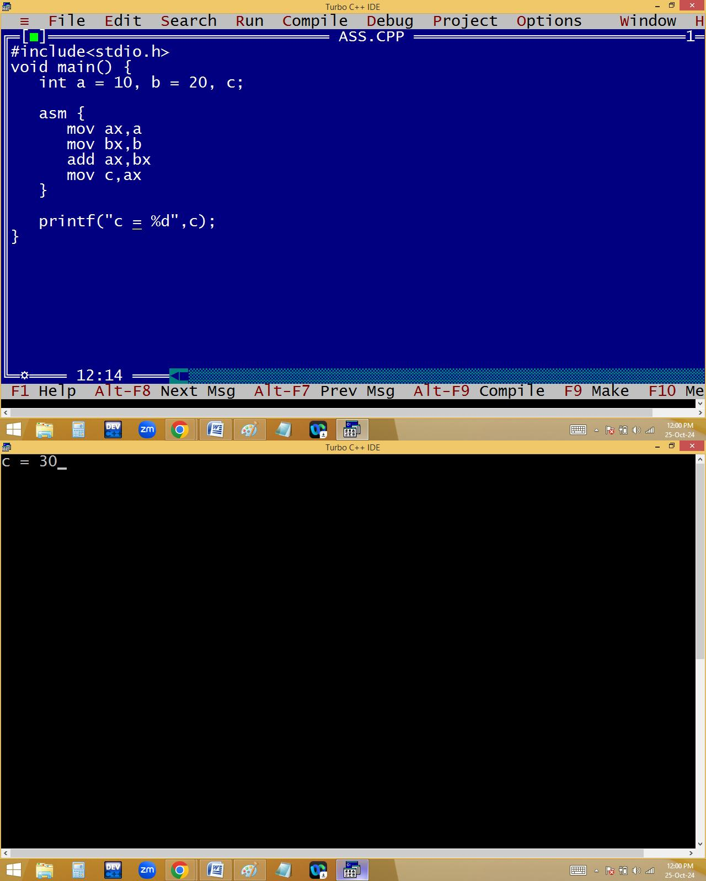
- High level language: Created with simple English. Hence they are easy to understand.

Eg: addition, subtraction,…. Example for high level language:

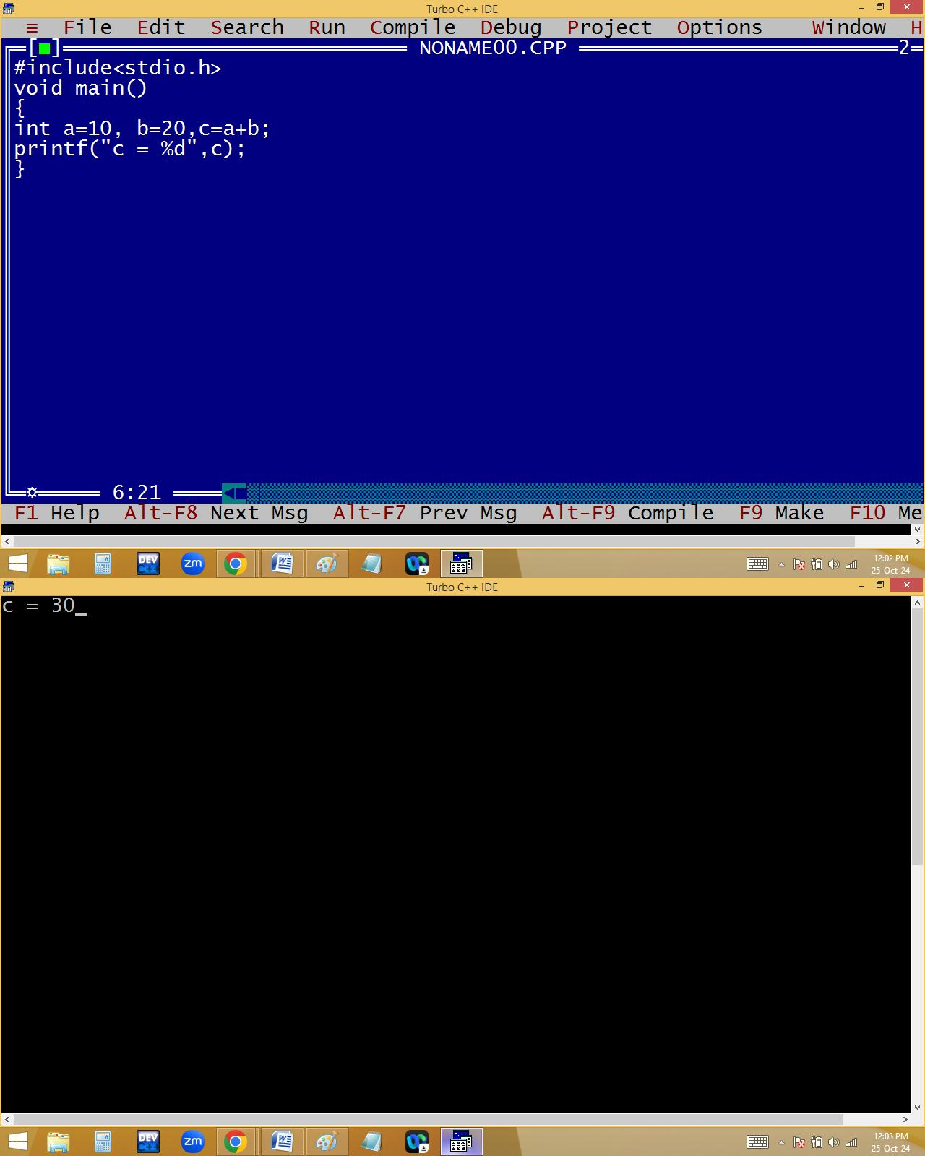
C comes with both low level and high level features. Hence c is also called it is a middle level programming language.

The C low level features used to develop system software and high level features used to develop application software. Hence c is also called it is a multi-purpose programming language.
- C is a compiler based programming language. What is a translator?
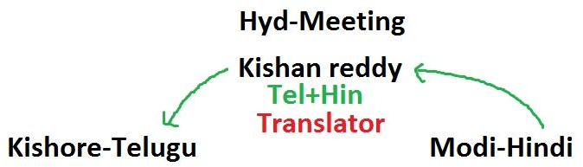

Always the programmer / user given instructions are in English, which is called source code / source program. But the computer understandable code is machine language / binary code. To convert this source code into binary code and to check the programming mistakes [Errors] we are using translators like
  - Compiler
  - Interpreter
  - Assembler
Compiler and interpreter used to convert high level programs to machine language.

Compiler converts the total program / source code into binary code at once by leaving error lines.
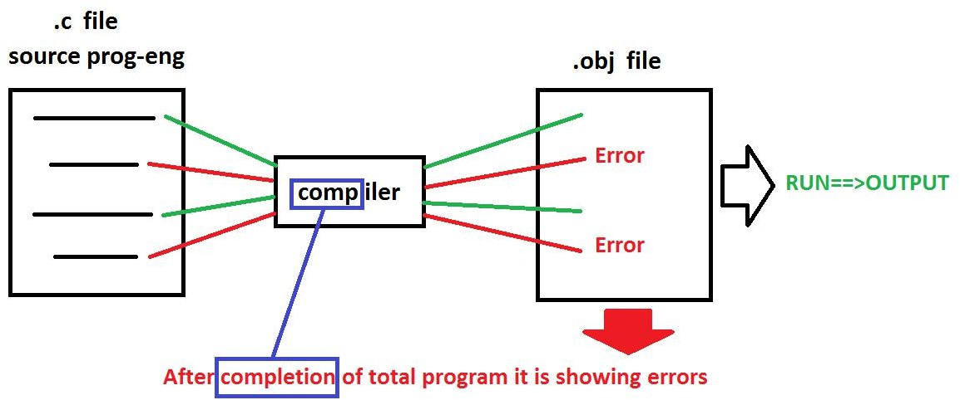
Interpreter converts line by line.

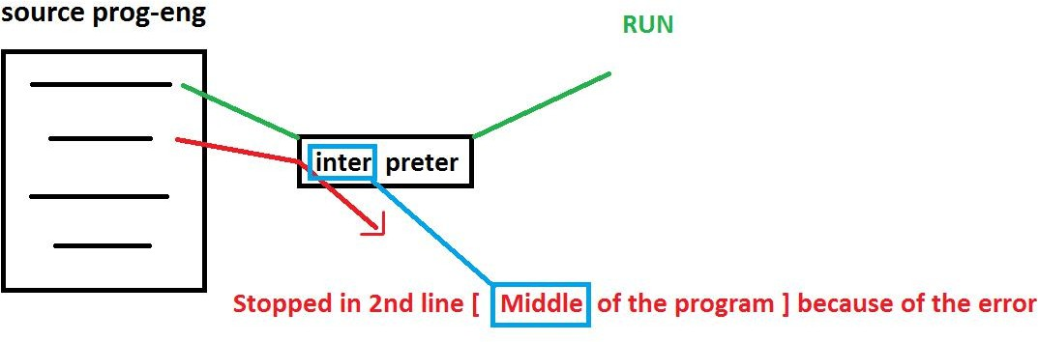

Assembler working style is similar to compiler.
Assembler used to convert low level programs to machine language.

In C we are using compiler as a translator. Hence it is called compiler based programming language.
In jave we are using compiler and interpreter. Hence it is called compiler based interpreted language.
- C is a procedure oriented programming language [POP’s]. What is programming paradigm?
Every programming language comes with a particular structure with rules and regulations, which is technically called programming paradigm.
Before C language, the languages are using Monolithic programming structure, which comes with single program. Due to this it is very difficult to identify the errors, take more memory and execution speed is less. In monolithic programming we can’t use part of the program when it is required and every time we have to run the entire program.

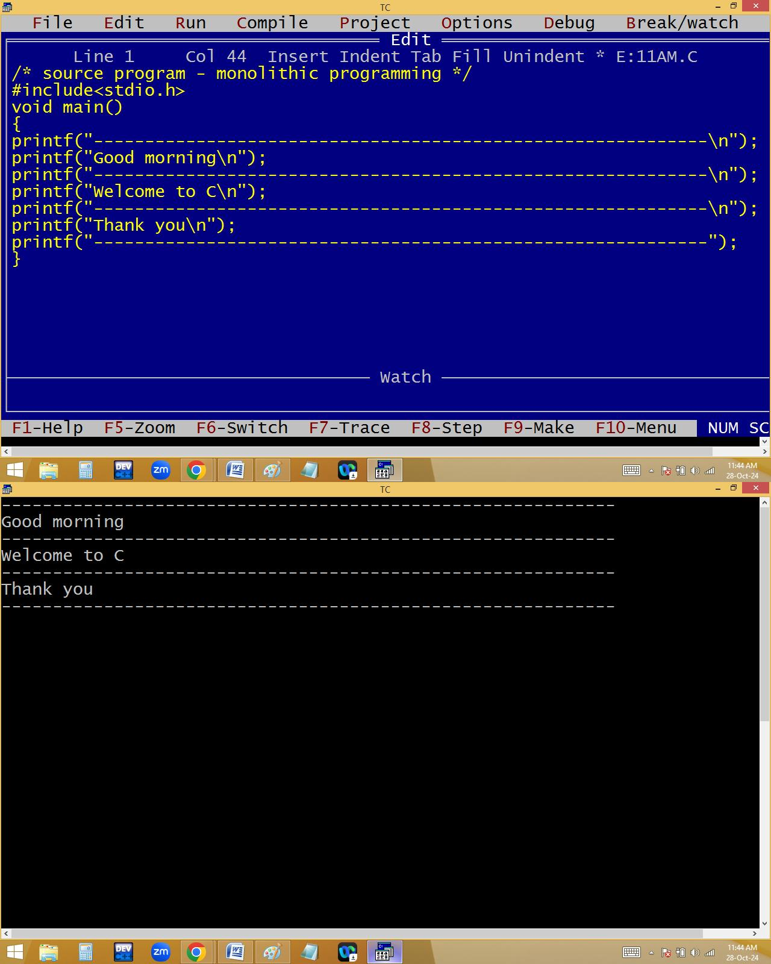
What is POP’s?

In Procedure oriented programming structure, the big programs are divided into several small sub programs / sub routines / procedures / functions / modules / structures. Hence c program is collection of procedures, it is called POP’s.
Advantages:
  - Modularity: Dividing big program into small pieces according to the program requirement.
  - Reusability: Write once, use many times.
  - Simplicity: Easy to understand the program
  - Efficiency: Performance is high.

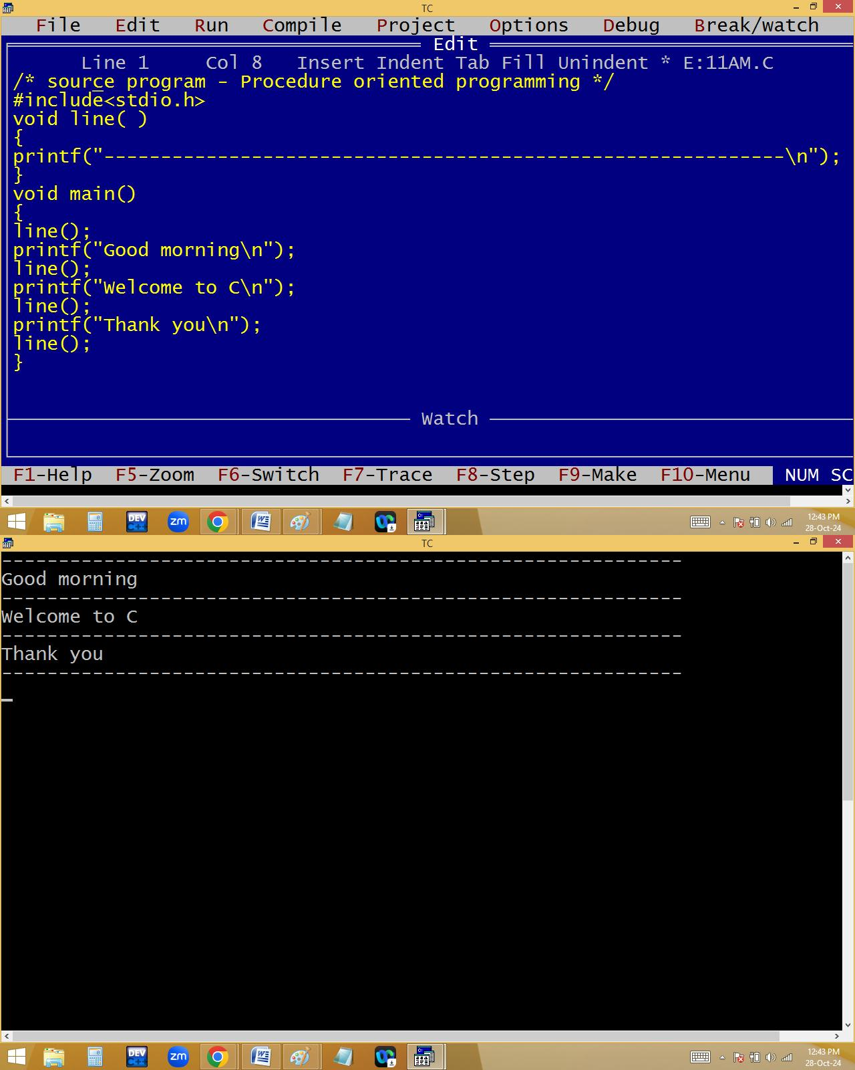

2
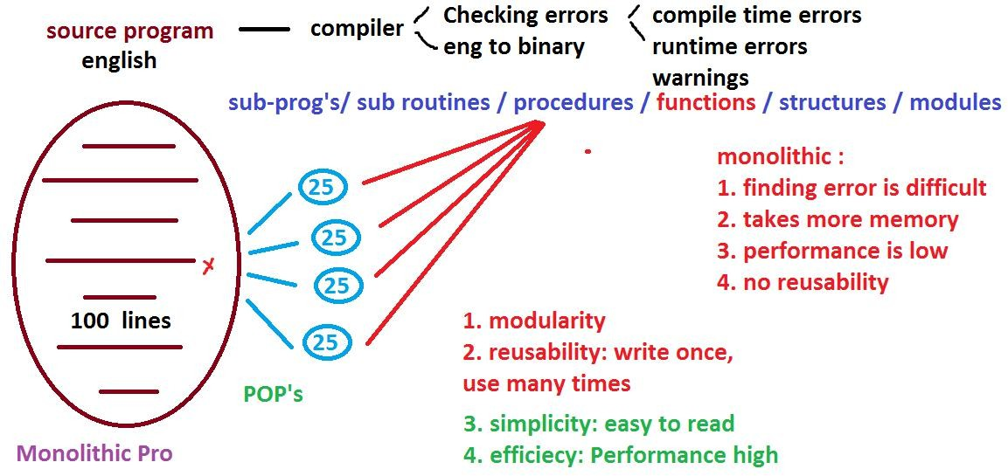

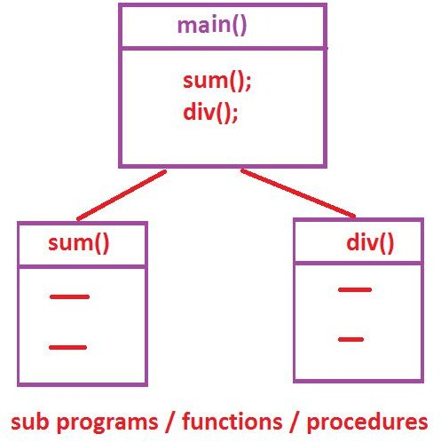

POP Drawback:
Data is not secured because of data is public. OOP’s: Object Oriented Programming structure Features:
- Class
- Object
- Data hiding

- Encapsulation
- Inheritance
- Polymorphism
- Abstraction etc

C supports Only the POP’s
C++ and Python having POP’s and OOP’s. hence they are called multi paradigm programming language.
Java supports only OOP’s.
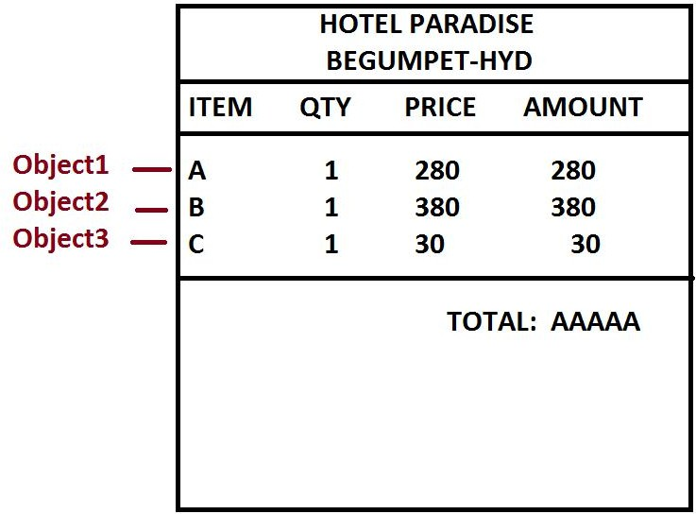
- C is a General purpose / multi-purpose programming language.

Using C language we can develop different type of applications / software like
  - Operating systems
Eg: windows, unix, linux, android, mac,…
  - Editors
Eg: Ms-Word, Notepad, Wordpad, Edit+,…
  - Translators
Eg: compiler, interpreter, assembler
  - Data base
Eg: Oracle, My SQL, SQL Server, Mongo DB, DBII,….
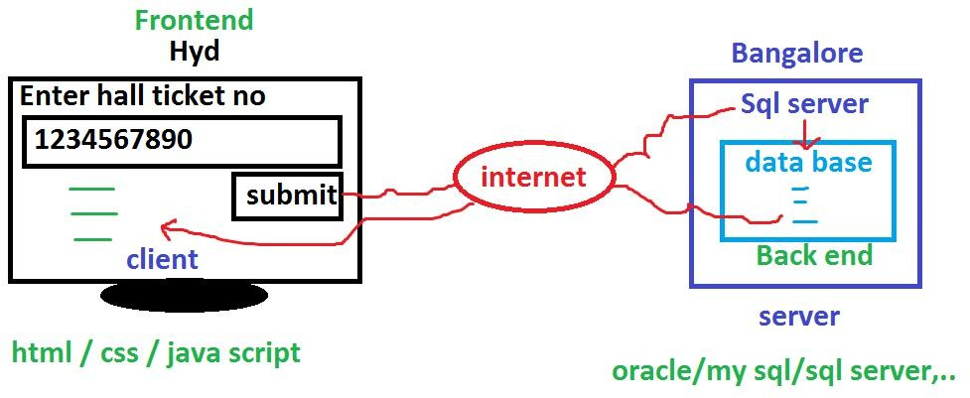

  - Commercial applications
Eg: hotel / college / super market / atm ,….
  - Device drivers
Eg: audio / video / printer / usb drivers etc.
  - Embedded applications

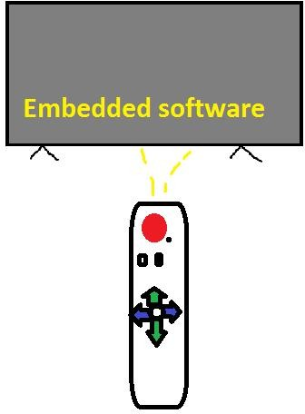

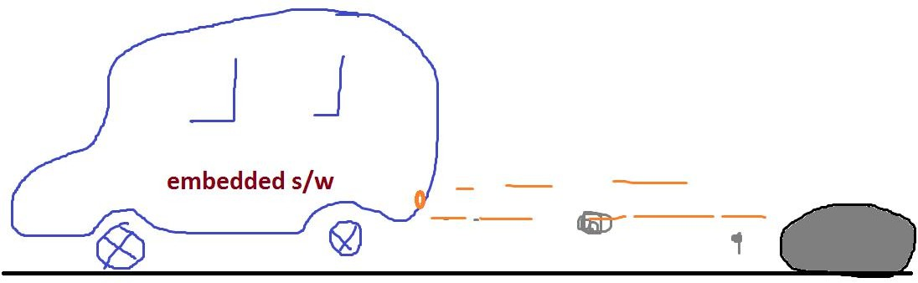
  - Anti virus
Eg: avast, macfee, nod,…
  - Media players

Eg: vlc, mx-player, windows media player,….
  - browsers
eg: chrome, firefox,…
  - PC & Mobile games
  - Any kind of standalone applications

HISTORY OF C
Basically C language introduced in 1972 by “Dennis Ritchie”, one of the software engineer in AT & T Bell labs [ American Telephone and Telegraph], located at Murray Hills, New Jersy, USA.
Ritchie adopted C language from B language, designed by “Ken Thomson”, one of the software engineer in AT & T Bell labs.
Thomson adopted B language from BCPL [ Basic Combined Programming Language ], designed by “Martien Richards”, an Assistant professor in Cambridge University.
In 1989 ANSI [ American National Standards Institute ] released a new version of C language with the name “ANSI-C”, which is familiar with the name “C-89”.
In 1999 ISO [ International Standard Organization ] released a new version of C with the name ”C-99”.

Basically C language designed to rewrite UNIX operating system.
Nowadays we can create and execute a c program on any machine with any processor. i.e. we can execute the C program on 80386 / 80486 / 80586 / intel core i3 / i5 / i7 / i9 / AMD Rayzon etc. Due to this c is called it is a machine independent programming language.
For example the languages like 8086 / 8088 are working only in 8086 / 8088 processors. Hence they are called machine dependent programming languages.
But c is a platform dependent programming language. i.e. the C application designed for one operating system is not working in another type of operating system. For example the C application created for windows is not working in UNIX / LINEX etc. Due to this problem using C language we can’t design web applications and we can only develop standalone applications with C language.

To design web applications we have to use the platform independent programming languages like java / .net / py etc. hence java is machine independent, platform independent, it is also called it is a portable language.
C is machine independent but platform dependent. Hence it is called it is a partial portable language.
Standalone applications installed in a single system [pc] and operated from that system only.
Web application installed in a web server and accessed throughout the world using web clients.

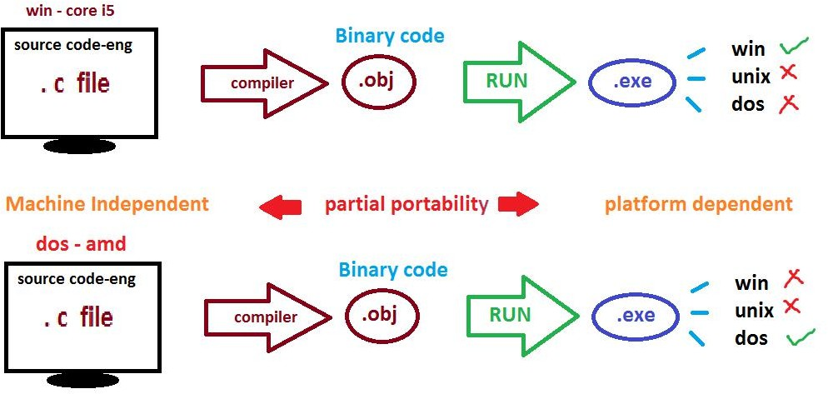

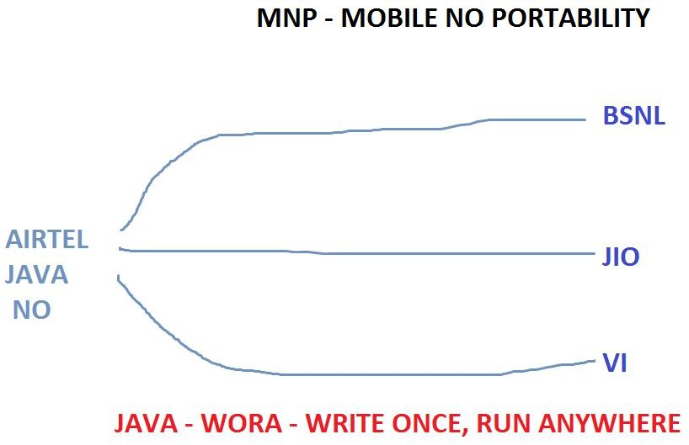

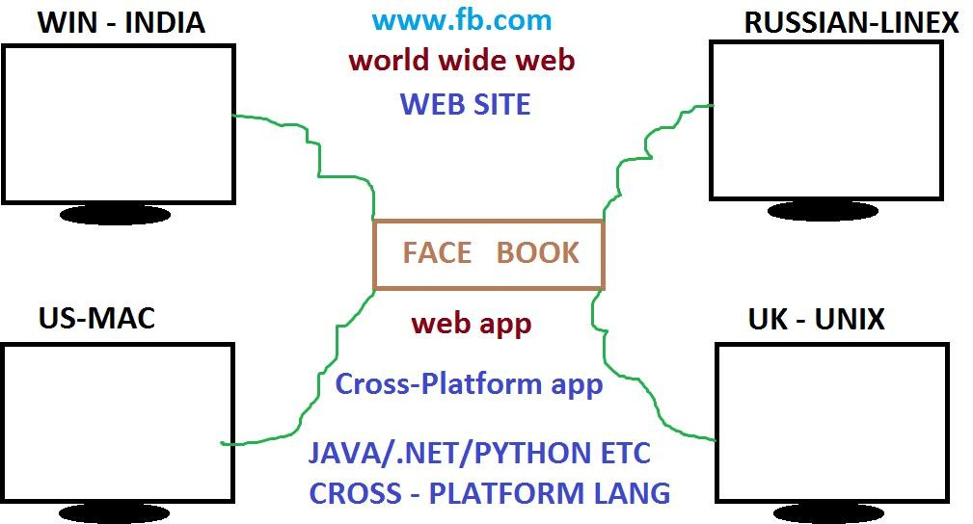
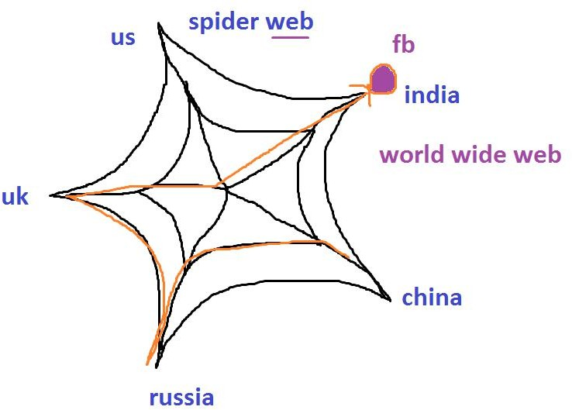

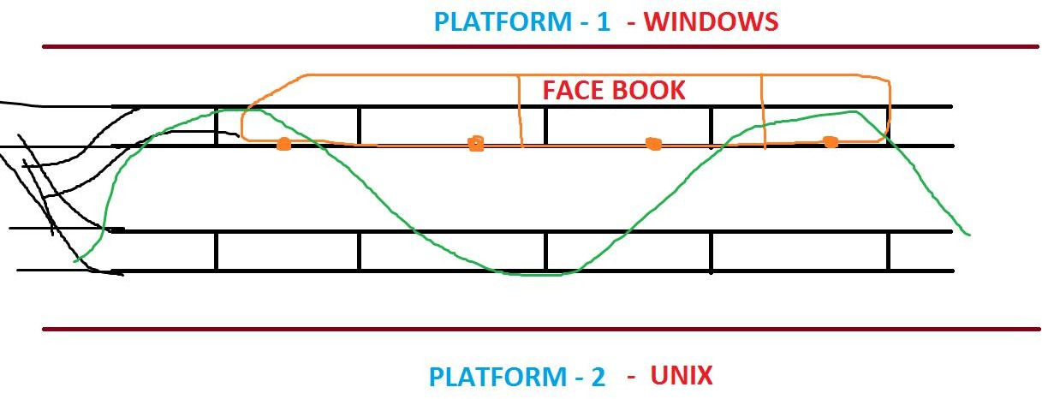

LAN – LOCAL AREA NETWORK – BUILDING / OFFICE
/ ROOM
MAN – METROPOLITAN AREA NETWORK – VILLAGE / TOWN / CITY – CITY CABLE
WAN – WIDE ARE NETWORK INTERNET – WEBSITES

https://nareshit.webex.com/nareshit/url.php?fro mpanel=false&gourl=https%3A%2F%2Fchat.whats app.com%2FEqBRfSPb41iHIS08fzelLA

Manoj – Admin for this class - 9154861171

FUNDAMENTALS OF C
C CHARACTER SET: Every programming language comes a particular character set and by using this character set only we can create the programs [ software ]. C comes with ASCII [ American Standard Code for Information Interchange ] character set, which is having 256 characters. In this 52 alphabets [ a-z, A-Z ], 10 digits [ 0-9 ], 44 operators [ +, -, *,… ], 14 separators [ , . ; “ “ { },… ] and remaining all are special characters.

ENGLISH LANGUAGE | C LANGUAGE
26 ALPHABETS | 256 ASCII VALUES
ENGLISH WORDS | C KEYWORDS – 32
ENGLISH SENTENSES | INSTRUCTIONS
ENGLISH PARAGRAPHS | PROGRAMS
ENGLISH DOCUMENTS | SOFTWARE
Generally user ASCII values:

Characters | Ascii values
a-z | 97-122
A-Z | 65-90
0-9 | 48-57
* | 42
+ | 43
Space bar | 32
Tab key | 9
Back space | 8
Esc | 27
Enter | 10

C & C++ ➔ ASCII CHARACTER SET – 256 CHAR’S

JAVA / .NET / PY – UNICODE – UNIVERSAL CODE – 65536 CHAR’S WEB APP’S
C PROGRAM COMPILATION AND EXECUTION PROCESS:
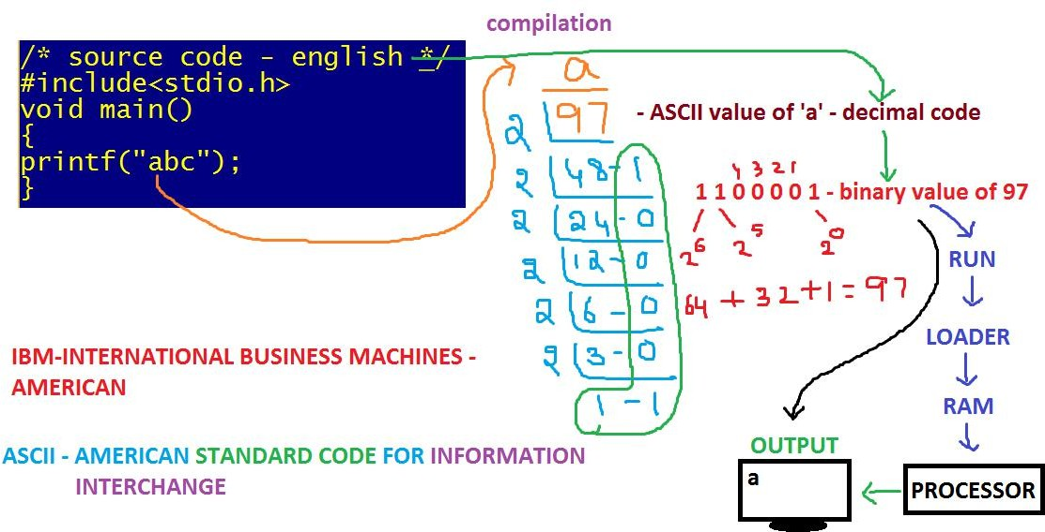

C - TOKENS
The smallest individual words we are using in developing a c program are called c – tokens. They are of different types.
- Keywords: The system predefined / reserved words are called keywords. Each keyword is having certain meaning and we can’t change this meaning. C comes with 32 keywords.
Eg: auto, break, const, continue, case, do, double, default, enum, else, for, float, goto, long, while, switch, typedef, register, static, unsigned,….
- Identifiers: Names of variables / functions / files / array / pointers etc.

Example for variables:
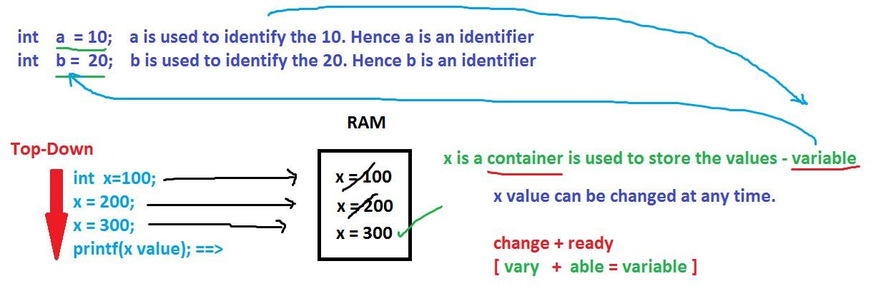

Example for functions:

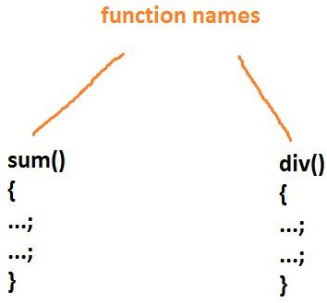

Example for files:
a.c, b.cpp, c.java, d.py,…
example for array:
int a[10]; ⬅ int array variable
example for pointer:
int * p ; int pointer variable

Identifier naming rules:

